Database Management System

(CT – 257)

Second Year

Spring Semester



**Project Members**

1. Saim Akhtar CT-059
2. Mauvia Atif CT-074
3. Saadat Hassan CT-040

Batch: **2017**

Submitted To: **Sir Umer Farooq**

Department: **BCIT**

Introduction:

NED University of Engineering And Technology comprises of many talented and skilled students and teachers. It’s one of the most renowned institutes of Pakistan. As there are students who get help from the notes and the books which are related to their subject. To save their effective time, it’s easy for them if they can access the materials by just using a single platform instead of roaming around the google.

Problems:

The issue which arose the need for this application is that when it’s about using the proficient time of the student, every student aspire to manage and consume their time effectively. While preparing for their course, they need to ask for the books to other students, teachers , their friends and sometimes when they fail to find one, they just go for the google option and search for a relevant book related to their interest which takes a lot of their time.

Also when they have the course material and books for a particular course, they aspire to share it but got no resources to help out everyone

That is when this idea triggered to save their time and give them a platform where they can contribute with each other

Aims & Objectives:

As discussed earlier how we got this idea, the main aim behind this project is providing a platform for the student, teachers, and also the outsiders, if they all can work together and provide books and study materials.

Using this database, we can have the records of all the books, the people who uploaded them, their departments ( if they are not outsiders) and their contact info. So as to contact them when needed any kind of help.

Not just storing the books in database, books also they are related to their courses so if would become quite easy for a user just by referring to their course, they can receive all their books

Fact Finding:

Let’s get started with searching for the facts:

Interviewing:

Asking the Students:

Q) Does it take your time when you are preparing for your exams and also searching for the relevant book?

Q) If it takes your time, are you comfortable with it?

Q) How much time would you use on your other skill instead of using it for just searching some material stuff?

Q) What if you are provided all the material you need only on just one platform?

Q) Suppose you are having a course of Data Structures, while you aspire to learn more about it and go to your teachers and seniors which books you should use to study it. Every one of them will suggest something different that would confuse you?

Q) What you just type in “Data Structures” and you get all the books related to this and who have uploaded this? So in future you can contact them? Sounds good right?

Q) While you have an urgency looking for a book, isn’t that easy you refer to you course and get your desired books?

Q) When you have the books related to the course of your field but you cant share them to every student of the field, do you think of any easy access at that time so everyone can get help from the resource?

Asking the Teacher:

Q) When there are students asking for the books for a course you are teaching, what if you have a hard copy of it but can’t share with them on a soft copy?

Q) Is it easy for you to get them the photocopy of the notes you have? if you have the facility of providing them on soft copies ?

Q) Also as a teacher when you want to get easy and free access to books, does it take your time searching for books? Related to the course you are teaching

Scenario Of The Project:

Let’s just first have the look of the user who is searching for a book, when the user visit the website, he go for the courses and search its books and then he get to list of all the books which he can download. Also he can check who have uploaded a relevant book so he can directly contact the uploader for future help

Now let’s have a look on the uploader, first if you are not an admin, you’ll have to create a user account to become member of the community. As you have an account now , you can upload a book and select the course related to this book regardless of which department it belongs.

ERD:

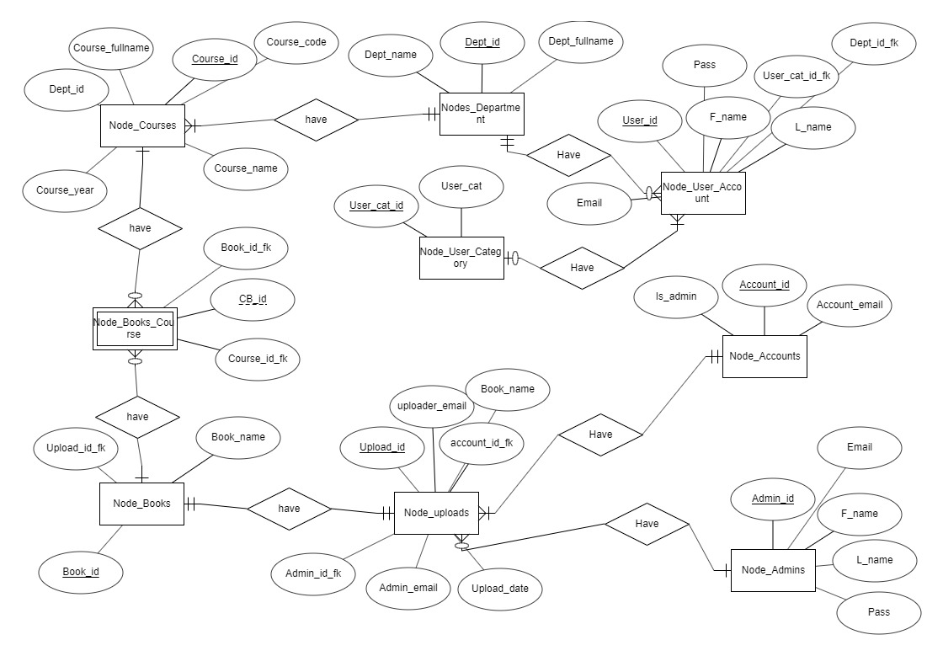

Normalization:

The table in the database are normalized in 3NF form. One of the examples is the relation between books and courses.

Here we have many to many relationship between books and courses so we have created a weak entity here named as ‘books_courses’. The primary key of the courses is used as a foreign key in the weak entity, similarly primary key of books is used as a foreign key in weak entity.

To make a 3NF form in the database, we have an example of reducing the transitive functional dependency. In the user_account table we have the column named as user_cat_id which refers to what is the category of the user ( faculty, student , outsider). These categories are separated in another table named as User_category where each one has their primary key associated. The primary key of user_category table is used as foreign key in user_account table.

The department contains many courses. So it has one to many relationship with the courses table

Physical Schema:

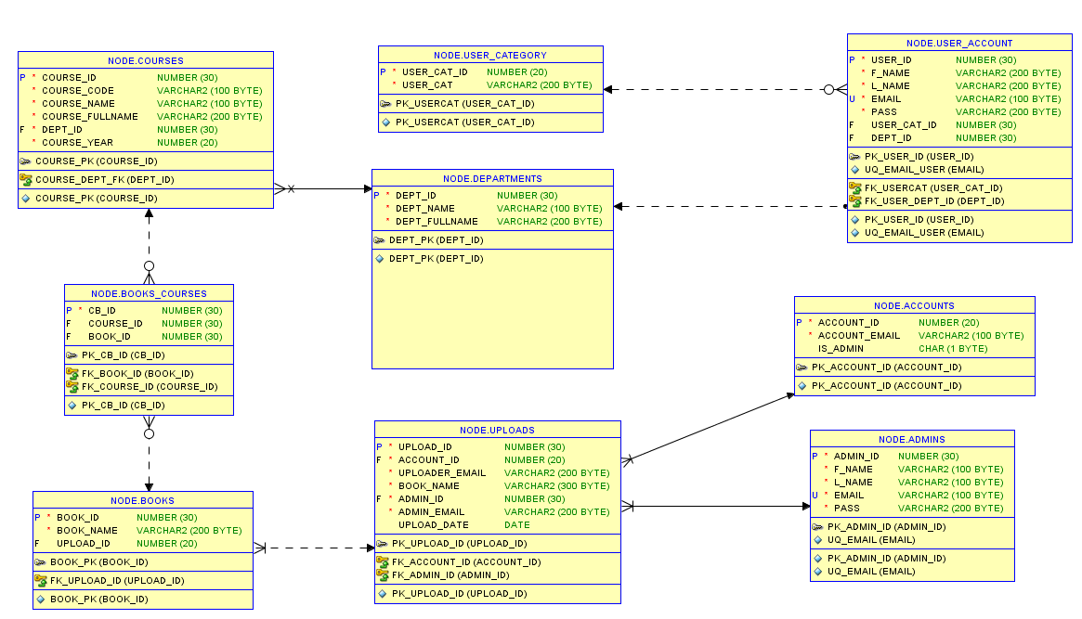

Queries:

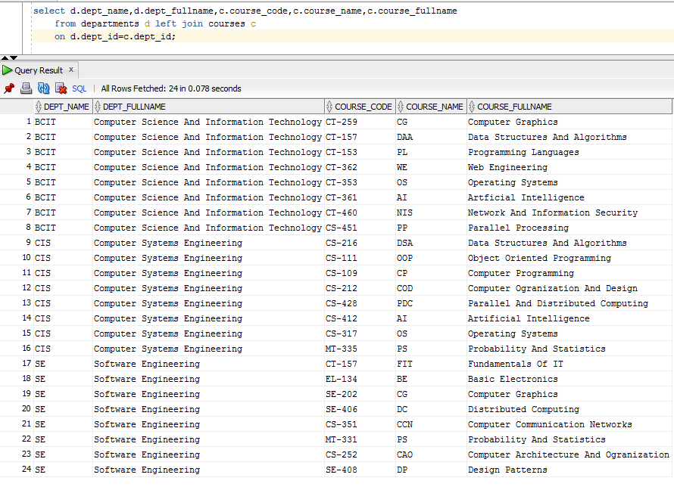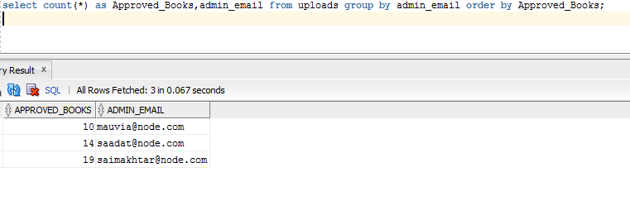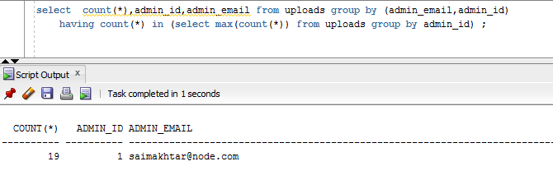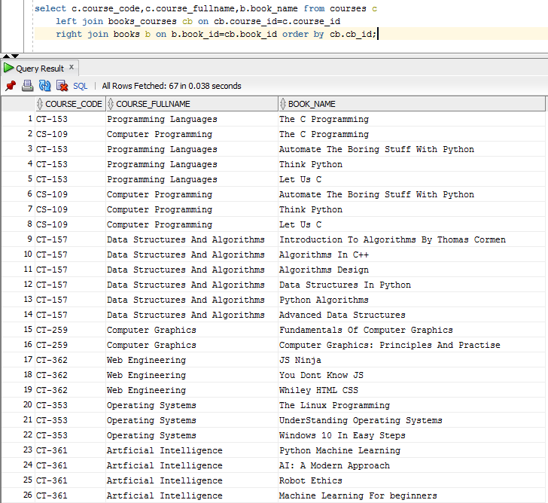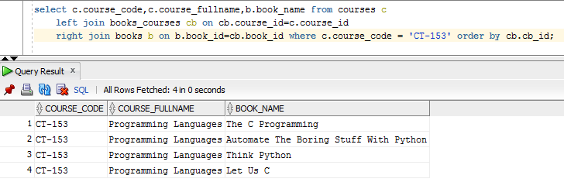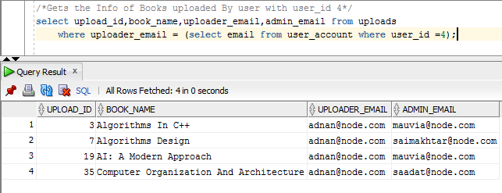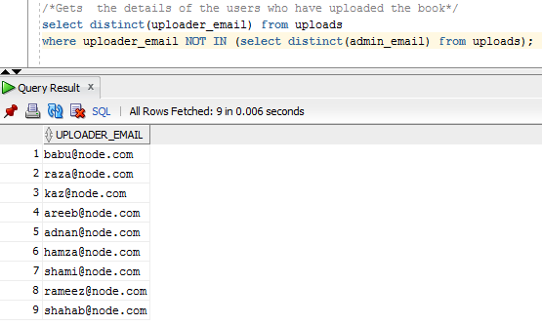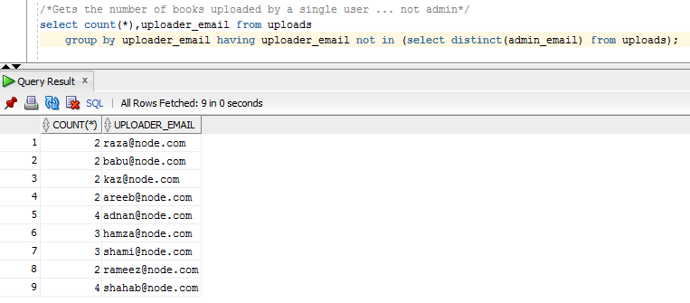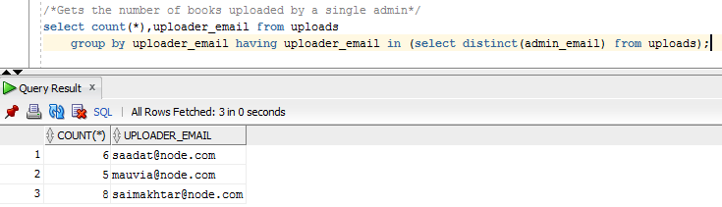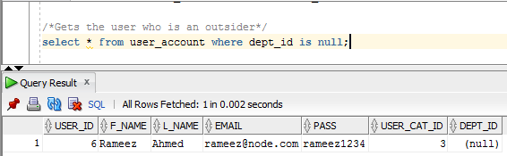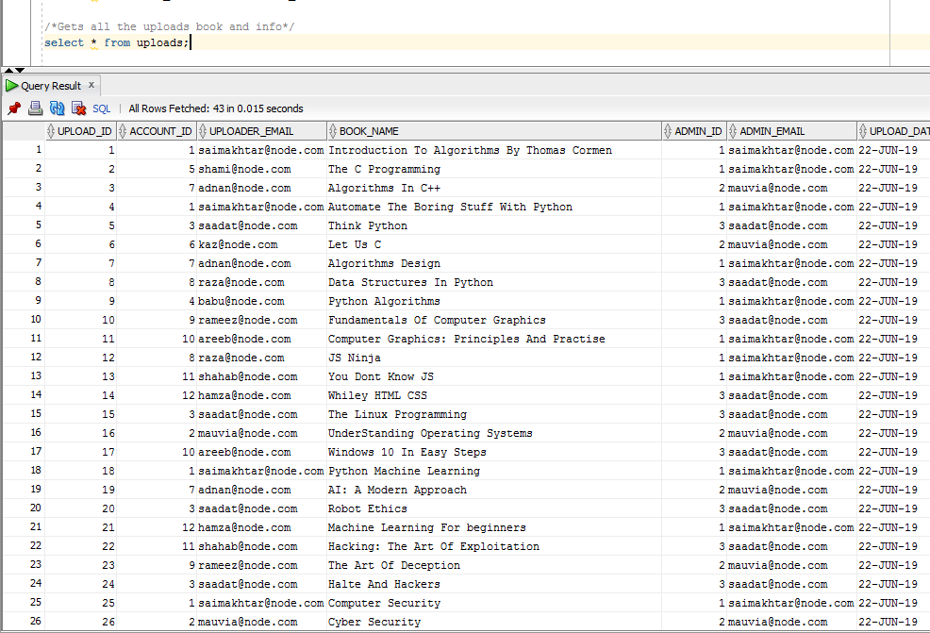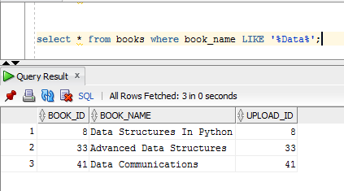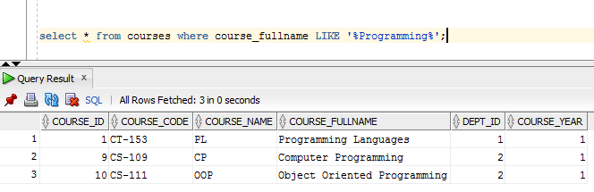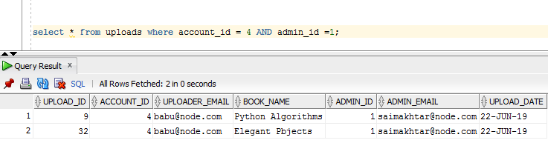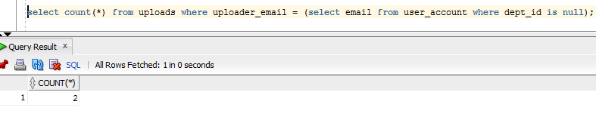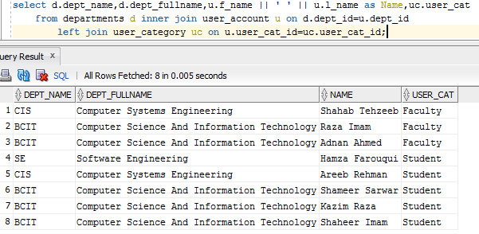

Future Work:

The future aspect of this project hold many important features.

If it gets successful in holding and managing such large amount of data, then we would create sessions and chat rooms in the application, where the user can directly contact the admin and uploaders in that particular session. Also it would allow the user to ask for or recommend books to be added in the list so that they can get quick response of their request.

This project can be used by any institution which aspire to create time efficiency of theihr members